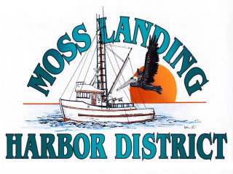

AD HOC
BUDGET COMMITTEE MEETING

Wednesday April 9, 2025 at 5pm

MOSS LANDING HARBOR DISTRICT
CONFERENCE ROOM

AGENDA: Discuss Preliminary Budget for Fiscal Year 2025/26

