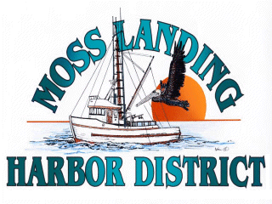 **AGENDA**

**SPECIAL MEETING**

**OF THE BOARD OF HARBOR COMMISSIONERS**

**PLANNING WORKSHOP**

**March 22, 2025 AT 9:00 A.M.**

**MOSS LANDING HARBOR DISTRICT**

**7881 SANDHOLDT ROAD, MOSS LANDING, CA 95039**

# a. OPEN SESSION CALL TO ORDER - PLEDGE OF ALLEGIANCE – ROLL CALL

Russ Jeffries – President Tommy Razzeca – General Manager

Vince Ferrante – Vice President Mike Rodriquez – District Counsel

James Goulart – Secretary

Liz Soto – Commissioner

Albert Lomeli- Commissioner

# B. PUBLIC COMMENTS

Members of the general public may address the Board of Harbor Commissioners regarding any item that is not on the Agenda. The President may limit the total amount of time of testimony.

# c. PLANNING WORKSHOP

1. The GM will present a list of upcoming projects already scheduled and potential future projects for Board discussion and consideration

A. Public Comment -

B. Board Discussion -

C. General Board Direction -

# D. aDJORNMENT

The next Meeting of the Board of Harbor Commissioners is scheduled for April 23, 2025 at 7:00 PM at the Moss Landing Harbor District, 7881 Sandholdt Road, Moss Landing, CA. Individuals requiring special accommodations should contact Administrative Assistant, Shay Shaw at [Shaw@mosslandingharbor.dst.ca.us](mailto:Shaw@mosslandingharbor.dst.ca.us) or at 831.633.5417 no less than 72 hours prior to the meeting or if a Special Meeting, as soon as possible after the Agenda is posted. Copies of the agenda will be available 72 hours prior to Regular Meetings and 24 hours prior to Special Meetings and/or by contacting the District at 831.633.5417 or Shaw[@mosslandingharbor.dst.ca.us](http://@mosslandingharbor.dst.ca.us) or on the District’s website at [www.mosslandingharbor.dst.ca.us](http://www.mosslandingharbor.dst.ca.us). All meetings are noticed and conducted in accordance with the Ralph M. Brown Act